OUTPUT:
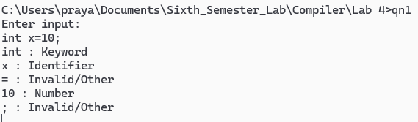

OUTPUT:
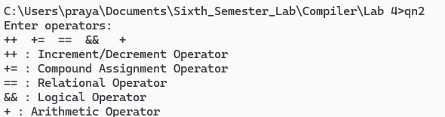

OUTPUT:
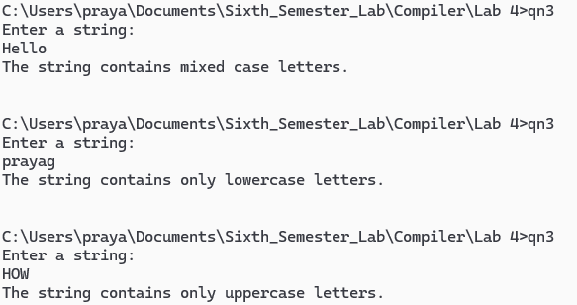

OUTPUT:
